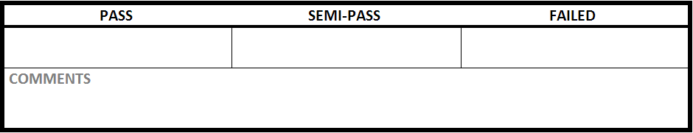

|  |  |
| --- | --- |
| Test Case #:LGN1.5 | Test Case Name:Login |
| System: Rec Warehouse | Subsystem:Login |
| Designed by: Rec Team | Design Date: February 2014 |
| Executed by: | Execution Date: |

|  |
| --- |
| Short Description: unsuccessful change of user PIN |

|  |
| --- |
| Preconditions: logged in to the system |

|  |  |  |  |  |
| --- | --- | --- | --- | --- |
| Step | Action | Expected System Response | Pass/Fail | Comment |
| 1 | click on username | redirected to the change PIN page |  |  |
| 2 | enter ‘1234’ into current PIN | displays **** in current PIN |  |  |
| 3 | enter ‘4321’ into new PIN | displays **** in new PIN |  |  |
| 4 | enter ‘4331’ into confirm PIN | Displays **** in confirm PIN |  |  |
| 5 | click submit | displays error message indicating the new PIN and confirm PIN |  |  |

|  |
| --- |
| Postconditions:at the change PIN screen |